*Hi, you need to prepare each solution in a separate word document by following the below settings.*

**MS Word files general settings**

**Version**

We prefer that MS Word 2010 be used—however, we understand that you may have an older version of Word installed. We accept Word files that are saved with .docx extension only

**Margins**

**Page Layout > Page Setup > Margins**

In the MS Word file, set the page margins (*File -> Page layout > Page Setup (Click on the arrow at the bottom to expand the menu) > Margins*) as:

**a.** Top and Bottom: 1” (Inches)

**b.** Left and Right: 1.25” (Inches)

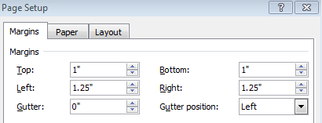

**Orientation**

Set orientation of the page to ‘Portrait’.

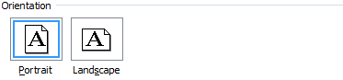

**Paper Size**

In the MS Word file, set the paper size (*File -> Page layout-> Page Setup-> Paper*) as:

**a.** Page Width: 8.5” (inches)

**b.** Page Height: 21” (inches)

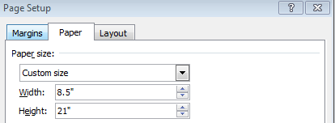

Press “OK”

**Line Spacing & Alignment**

Set line spacing to ‘Single’

The default alignment option should be “Justify (Ctrl+J)” in Paragraph settings (Home->Paragraph)

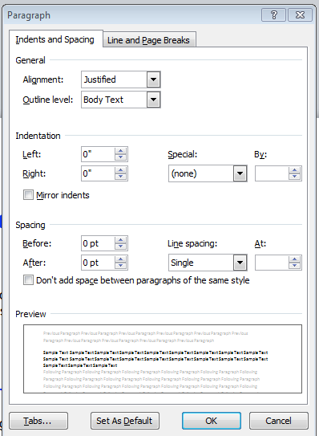

**Font Settings**

Font: Times New Roman

Size: 12

**Language**

The default language setting should be English (United States).

**How to save the word file?**

**Filename**

Each solution file should be typed in a *separate* ***Word file***and named using the ***Following notation:***

<**Book ID**>**-**<**chapter number**>**.**<**section number**>**-**<**problem number**>

***For example***: **1738-5.4-35P**

Here,

• **1738** is the book ID. Every textbook has a unique numerical Book

ID, assigned by Chegg, for ease of reference

• **5.4** indicates chapter 5, section 4 of the textbook

• **35P** is the problem number

Some textbooks have chapters that are not sub-divided into sections—the list of solutions given to you by your territory manager will make it clear if your book has sub-sections or not. For textbooks without sub-sections in chapters, Word files should be named using the following notation:

<**Book ID**>**-**<**chapter number**>**-**<**problem number**>

The earlier example would then become: **1738-5-35P**.

***Important note*:** Do not ***prefix zeros*** to single-digit chapter and problem

numbers. **1738-5-35P** is the correct format for the sample shown above, and 1738-05-35P would be incorrect.

**Title**

The title is the topmost part on the first page of a solution**. Please note that the title should NOT be placed in a header section. Instead, the title should appear in the first line of the body of the Word document.**

The title has thefollowing parts:

**1. Filename:** Please refer above.

**2. AID: A**uthor’s **ID** is a unique identification number that is used to

identify the subject expert who has worked on a solution.

**3. Vertical bar “|”:** (available on your computer’s keyboard by pressing

SHIFT + “\”) The vertical bar simply serves to separate the AID and the

Date of Creation.

**4. Date of creation:** This is the date on which you submitted this solution

to us. If the solution is being resubmitted, use the resubmission date.

**Use dd/mm/yyyy format**.

**5. Delimiter:** This is a horizontal line that marks the end of the title

portion. Delimiters should be created by hitting dash three times (“---“),

then hitting ENTER. Delimiters created using any other method will be

rejected.

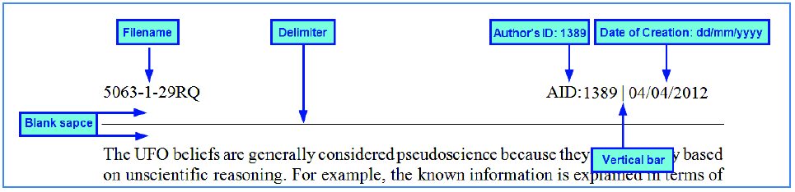

**Figure – 1**

**Don’ts**

Do not insert a delimiter in the following three situations:

• After the **last step** of a solution

• At the end of a page for solutions longer than one page

• At the beginning of a page for solutions longer than one page

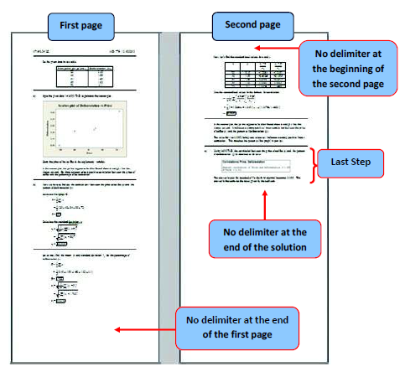

The screenshot below shows the structure of a typical solution and with the possible data objects labeled. The contents of the screenshot have been deliberately blurred

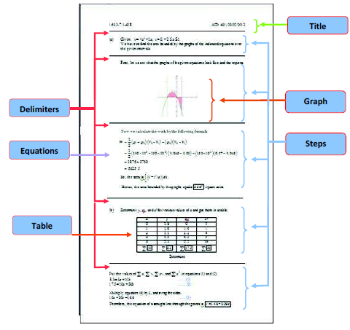

**Figure – 2**

**Content guidelines: text and equations**

Every step of a solution must contain one or more sentences. Some steps may contain additional items like equations, graphs, charts, or diagrams. The full list of contents that may be found in a solution is:

Text (Sentences)

Equations

Diagrams

Graphs

Tables

**Text**

* Every step in a solution must start with a sentence. Your sentences should both restate the relevant facts that will be used in the step and outline what will be accomplished within the step.
* Sentences should be short, grammatically correct, and easy to understand. Phrases should not be used in place of sentences.
* Sentences should be conversational and direct in tone.

For example: “Add the values” has a conversational and direct tone, while “One should take the summation of all the values” is neither conversational nor direct.

* If there are a number of consecutive sentences, group them into

paragraphs of not more than three, preferably short sentences.

* Colored, italicized, or bolded text, highlighting, or bullet points can

and should be used for emphasis. When coloring or highlighting text,

be sure to select colors that render the underlying text clearly visible.

Generally light colored (e.g. yellow, light green) highlighting and

medium-dark colored (e.g. blue or dark red) font should be used for

emphasis. Note that regular text should be black in color.

**Labeling of Subparts:**

If a problem consists of subparts like, (a), (b),…. etc., then they should be labeled in the following way:

• Type the subpart name in the same format as given in the problem [ For

Example: **Do not** type (A) in place of (a)]

• **Do not** type anything in the line containing the name of the subpart

• Leave the next line blank

• Start the opening sentence after the blank line

The below screenshot illustrates the method to label the subpart of a

solution.

